World Day of Prayer 2020 - 21
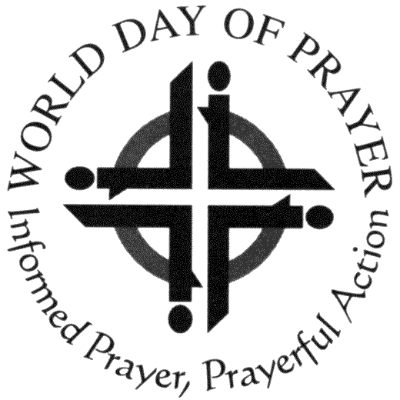
Scottish charity number SCO 020446

We now have badges and pendants for sale.
The pendants come with a chain and in a small presentation box.
They can be ordered from;
Mrs. Elizabeth Blair
4, Uist Terrace
Dundee
DD4 9TA
Tel; 01382 506658

 |  | Gold  colour | Silver  colour | Cost
Badges | @ £1.25
Pendants | @£4

From: Name ……………………………………………

Address …………………………………………...
…………………………………………………….
Post Code………………………………………….

Tel. No………………….…………………………

.

Please do not send money with your order as Elizabeth will add on the postage due and will send you an invoice with the articles.

