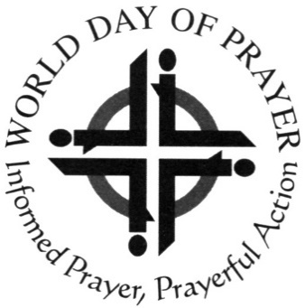
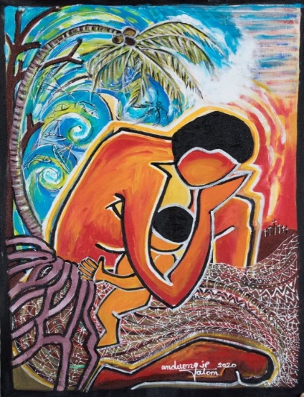
A warm welcome awaits you at your local service:
In

At

WORLD DAY OF PRAYER
Friday, 5th March 2021
‘Build on a strong foundation’
Written by Christian women of Vanuatu
All Welcome!

All
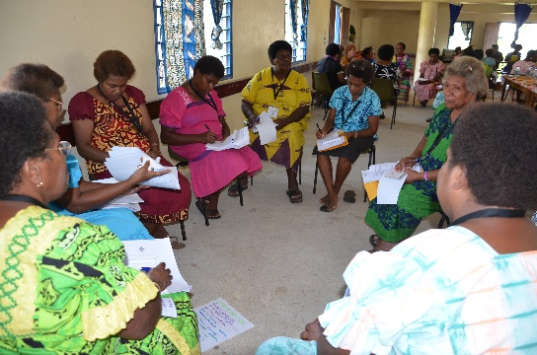
‘Where two or three
are gathered together
in my name…
there I will be also’
All Welcome!
Every year on (or near) the first FRIDAY in MARCH, Christians around the world (Protestants, Roman Catholics, Orthodox, Evangelicals) of all ages (women, men, young people and children) gather in small groups and large congregations using the same basic form of worship, written by women of a different country each year on a theme chosen by the World Day of Prayer International Committee.
‘Lord teach us to pray’
This year we pray with women of Vanuatu for
- Their everyday struggle with food production
- With caring for their environment
- And the education of their children
- For peace in their Nation
- That all may live in unity, in love and peace

In this service we think about God’s invitation: ‘Build on a strong foundation’ – are we ready to have Jesus as our foundation?
For more information:

World Day of Prayer Scottish Committee--SC020446

