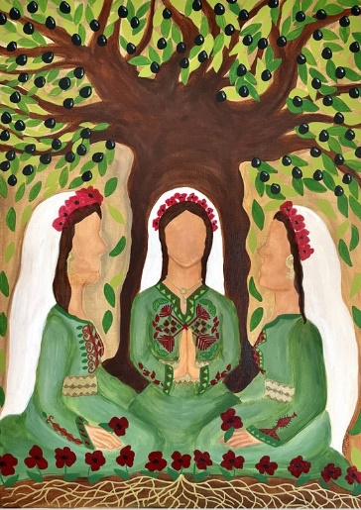**WORLD DAY OF**

**PRAYER**

**Friday 1st March 2024**

***“I beg you to bear with one another in love”***

*(Ephesians 4: 1-7)*

**Written by Christian Women**

**of**

**Palestine**

World Day of Prayer Scottish Committee SC020446