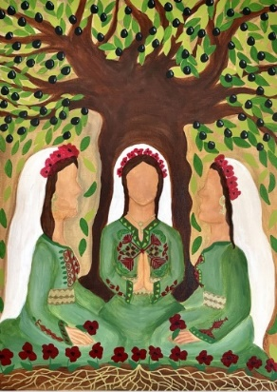
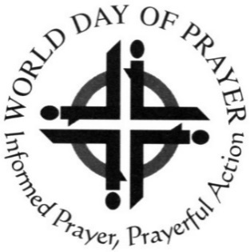

A warm welcome awaits you at your local service:

In

At

WORLD DAY OF PRAYER
Friday, 1st March 2024
‘I beg you to bear with one another in love’
Written by Christian women of
Palestine
All Welcome!

All
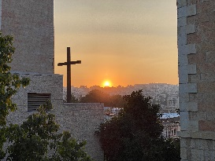
Palestine the land where Christianity was born!

About World Day of Prayer!
Every year on (or near) the first FRIDAY in MARCH, Christians around the world of all denominations and Church Groups and all ages gather in small groups and large congregations using the same basic form of worship, written by women of a different country each year on a theme chosen by the World Day of Prayer International Committee.
A group of ecumenical Palestinian Christian women have worked collectively the last 4 years to pray and reflect on the theme and they invite us to join them as they pray:-
- for peace
- for justice
- love and unity
‘Lord, teach us to pray’

Let us praise God who brings us together to worship in love and unity ‘I beg you to bear with one another in love’ (Ephesians 4: 1-7)
For more information on local plans, check with

and see WDP Scotland website for up-to-date information and zoom meetings

World Day of Prayer Scottish Committee--SC020446

