THE WORLD DAY OF PRAYER SCOTTISH COMMITTEE
INVITE YOU TO
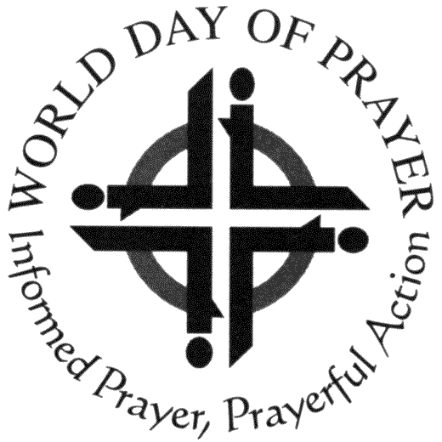
THE GATHERING

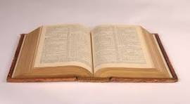
15th JUNE 2024
ST. MATTHEW’S CHURCH,
TAY ST., PERTH, PH1 5LQ

10.30AM – 3.30PM

THEME
‘We are Bearers of the Story’

All are welcome, no matter your age. We invite you
to come and join in Christian Fellowship on this
special occasion…
European & International
Representatives

Edith Toth
Senka Peterlin
Keynote Speakers

Lindsey Sanderson
Carol Bourne
Kathryn Howe
Kathy Galloway

TABLE CHAT
Praise and Worship

Registration to:- treasurer@wdpscotland.org.uk.
Telephone:- 07711 924144.
Or post to:- 4, Gateley Ave., Blyth, Northumberland, NE24 3HG
Scottish Charity Number:- Sco20446

PRAYER STATIONS
REFRESHMENTS

