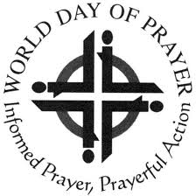
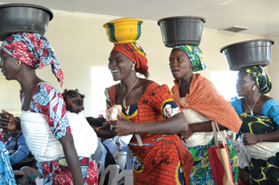

WORLD DAY OF PRAYER
Friday, 6th March 2026

‘I will give you rest: Come’

Written by Christian Women of
NIGERIA

All Welcome!

A warm welcome awaits you at your local service:

In

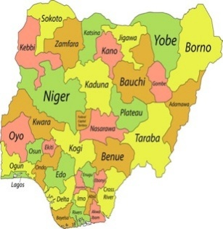
At NIGERIA
Christianity was introduced into Nigeria around the 15th century through European missionaries. It gained significant attraction in the 19th century, particularly in the southern and central regions. Today, Nigeria is home to one of the largest
Christian populations in Africa.

About World Day of Prayer!

Every year on (or near) the first FRIDAY in MARCH, Christians
around the world of all denominations and Church Groups and all
ages gather in groups using the same form of worship, written by women of a different country each year on a theme chosen by the World Day of Prayer International Committee.

A group of Christian women from Nigeria have worked
collectively the last 4 years to pray and reflect on the
theme and they invite us to join them as they pray:-

for peace
for justice
for grace

Let us praise God who brings us together to worship, to pray
for peace, justice and grace

‘I will give you rest: Come’

For more information on local plans, check with

and see WDP Scotland website www.wdpscotland.org.uk
for up-to-date information

World Day of Prayer Scottish Committee—SC020446

