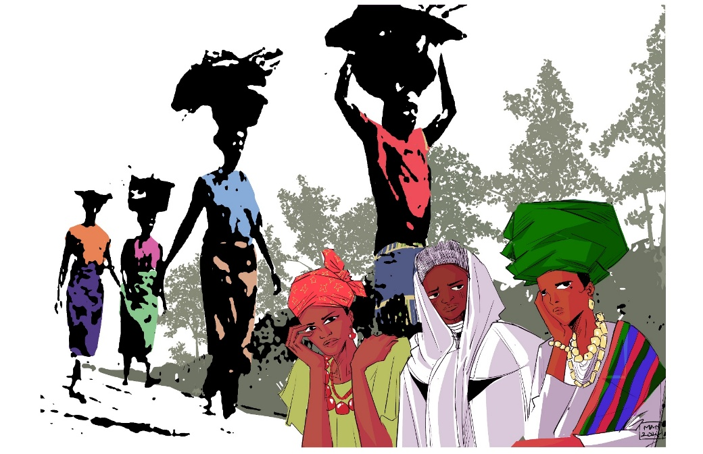

Friday 6th March 2026

“I will Give you rest: - Come”

Written by Christian Women
of Nigeria

World Day of Prayer Scottish Committee SC020446

