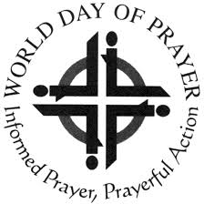
WORLD DAY OF PRAYER
SCOTTISH COMMITTEE

Press Release

Friday 6th March 2026
“I will give you rest: come”

The World Day of Prayer is a global ecumenical movement led by Christian women who welcome you to join in prayer and action for peace and justice. A service is held annually on or near the first Friday in March.

The service for 2026 was written by a group of ecumenical Nigerian Christian women. Nigeria is located on the western coast of Africa – the climate varies from equatorial in the south, tropical in the central regions and arid in the north. Nigeria has a population of over 211 million with over 250 ethnic groups; the three largest are the Hausa-Fulani, Yoruba and Igbo. Christianity is a major religious influence.

The writers of this service call us to find rest in God. The women explore different kinds of burden to help us understand both the weight of human suffering and the depths of divine compassion for those who are weary. Three women share their stories speaking to us about the suffering of widows, the shadow of religious persecution and the burdens of poverty which can bring despair. Their experiences show us how God provides rest through support from their community and their faith and hope in God.

The World Day of Prayer is for everyone - men, women and young people.

A warm welcome awaits you at your local service, and you are invited to share your faith, joy and hopes.

For further information and resources, together with details of services in your area, please see the World Day of Prayer Scotland website www.wdpscotland.org.uk

