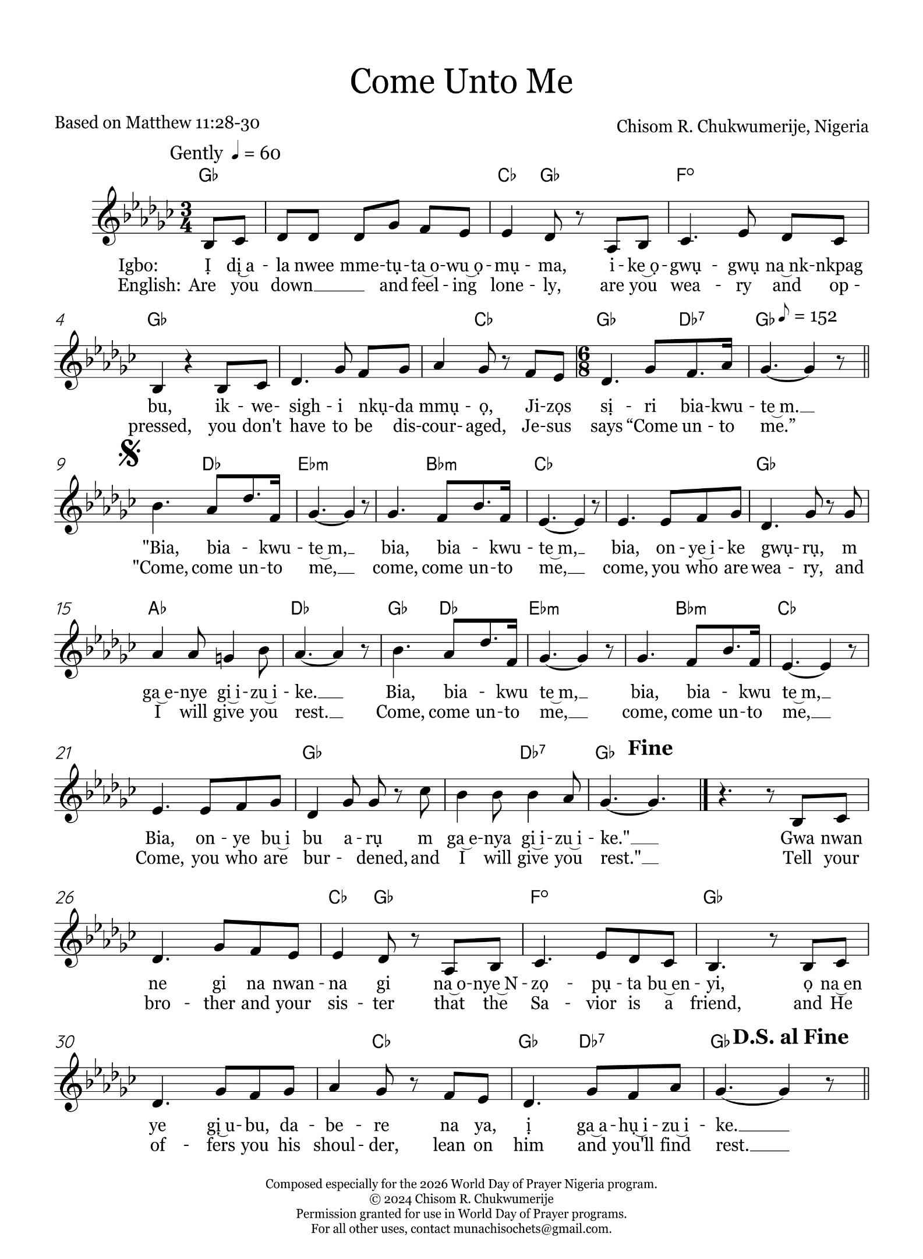

2
Igbo:
Ị dị ala nwee mmetụta owu ọmụma,
ike ọgwụgwụ na nkpagbu,
ikwesighi nkụda mmụọ,
Jizọs sịri biakwute m.

"Bia, biakwute m, (2x)
bịa, onye ike gwụrụ, m ga-enye gi-izu ike.
Bia, biakwute m, (2x)
bịa, onye bu ibu arụ m ga-enye gi-izu ike."

Gwa nwanne gi na nwanna gi, na onye Nzọpụta bu enyi,
ọ na enye gị ubu, dabere na ya, ị ga ahụ izu ike.

English:
Are you down and feeling lonely,
are you weary and oppressed,
you don't have to be discouraged,
Jesus says “Come unto me.”

"Come, come unto me, (2x)
come, you who are weary, and I will give you rest.
Come, come unto me, (2x)
Come, you who are burdened, and I will give you rest."

Tell your brother and your sister that the Saviour is a friend,
and He offers you his shoulder, lean on him and you'll find rest.

