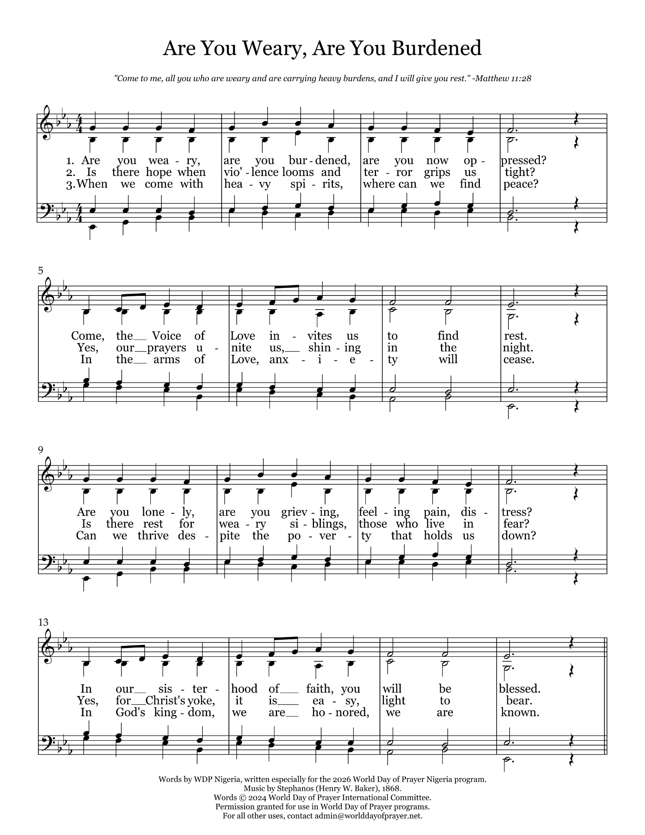

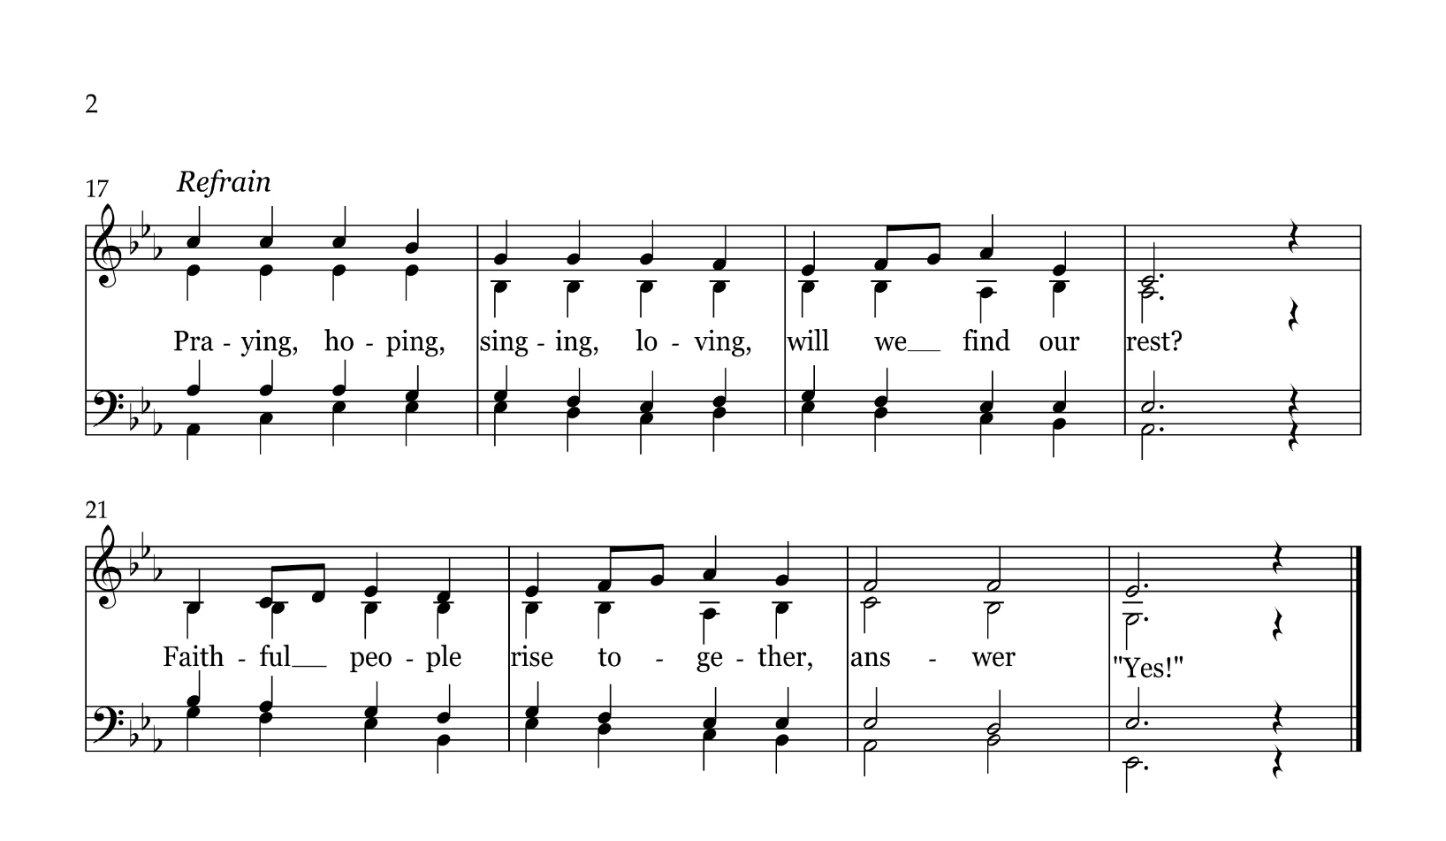

Are you weary, are you burdened, are you now oppressed?
Come, the Voice of Love invites us to find rest.
Are you lonely, are you grieving, feeling pain, distress?
In our sisterhood of faith, you will be blessed.

Refrain
Praying, hoping, singing, loving, will we find our rest?
Faithful people rise together, answer " Yes!"

Is there hope when vio’lence looms and terror grips us tight?
Yes, our prayers unite us, shining in the night.
Is there rest for weary siblings, those who live in fear?
Yes, for Christ's yoke, it is easy, light to bear.

When we come with heavy spirits, where can we find peace?
In the arms of Love, anxiety will cease.
Can we thrive despite the poverty that holds us down?
In God's kingdom, we are honoured, we are known.

